

Performance Test Report

Table of Contents
Table of Contents 2
Test Environment 3
Tool 3
Machine configuration 3
Virtual Machine 3
Server 3
Tool Configuration 3
Tests performed 3
Appendix 5
Links 10

Test Environment

Tool
- Apache JMeter Version 2.0.2 (available at http://jakarta.apache.org/jmeter/index.html)

Machine configuration

Hardware
Intel Pentium 4 CPU 2.8 GHz
512 MB RAM

Software
Windows XP Professional edition version 2002 with service pack 2

Virtual Machine
java version "1.4.2_04"
Java(TM) 2 Runtime Environment, Standard Edition (build 1.4.2_04-b05)
Java HotSpot(TM) Client VM (build 1.4.2_04-b05, mixed mode)

Server
Tomcat 4.1.29

Tool Configuration
500 requests per each type. The actual JMeter configuration file is included in the test resource bundle archive under the JMeter configuration folder.

Axis Versions
- Axis 1.2 RC1
- Axis 2.0 M1 Release (built from the latest code in svn repository)

Tests performed
The tests were carried in several stages
- Basic types
  - String array with 10 elements
  - String array with 100 elements
  - String array with 1000 elements
- Complex types
  - Complex structure array with 10 elements
  - Complex structure array with 100 elements
  - Complex structure array with 1000 elements

The results are condensed below. Please refer the appendix for the JMeter screenshots.

Axis Version | Basic - String |  |  | Complex - Structure
Axis Version | Array Size |  |  | Array Size
Axis Version | 10 | 100 | 1000 | 10 | 100 | 1000
1.2 | 16 | 24 | 109 | 31 | 147 | 1436
2 | 11 | 15 | 44 | 15 | 61 | 499

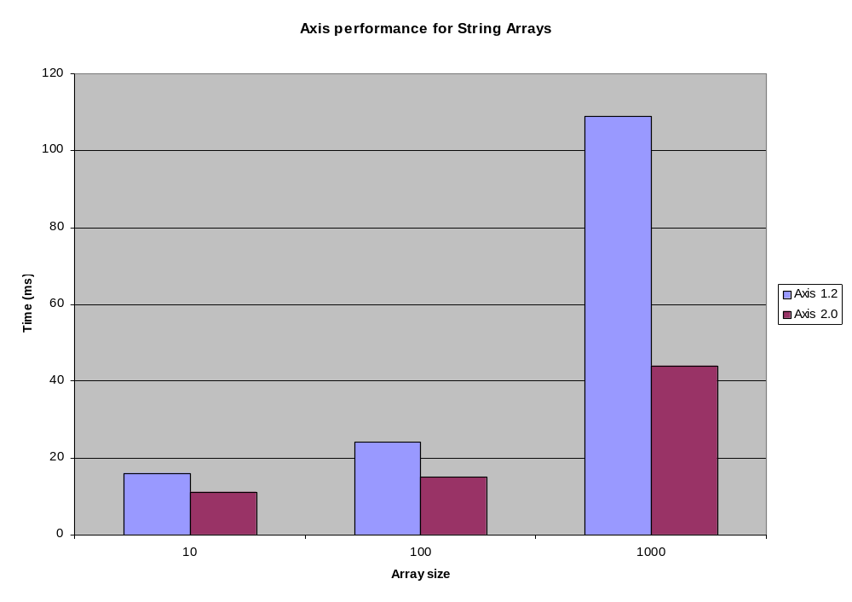
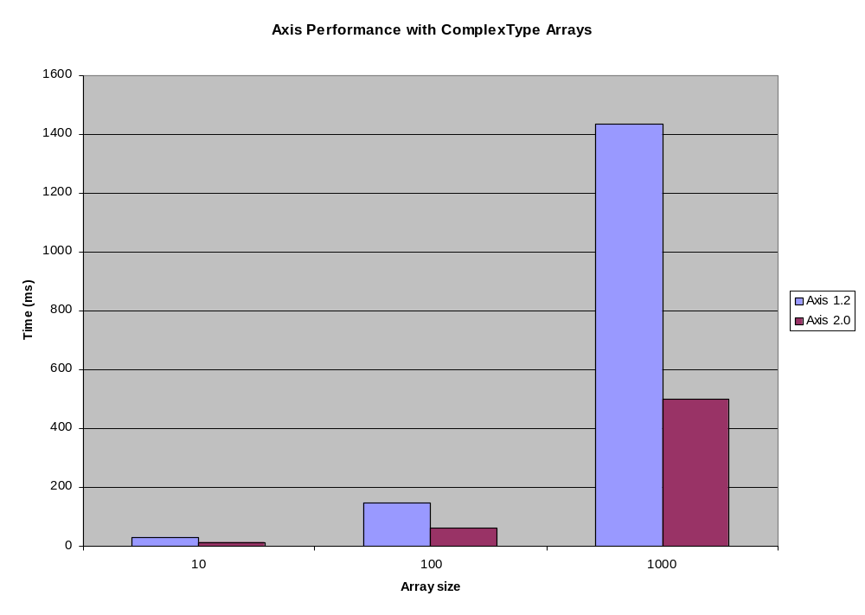

Appendix

Images
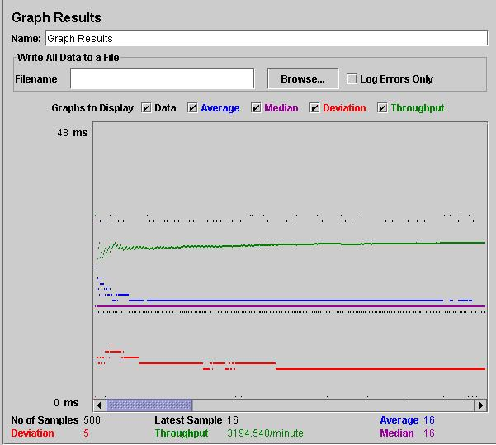 | String Array – 10 Elements – Axis 1.2
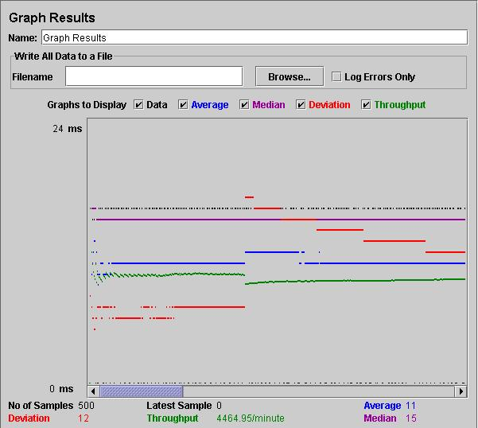 | String Array – 10 Elements – Axis 2.0

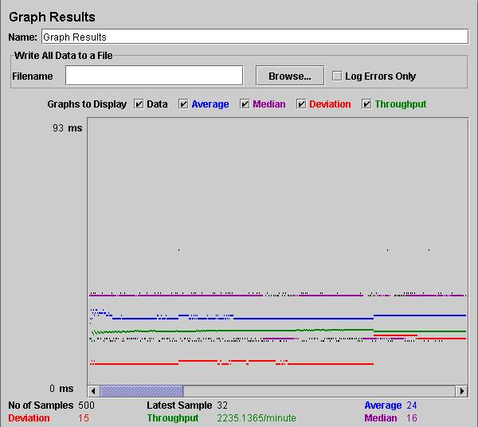 |  | String Array – 100 Elements – Axis 1.2
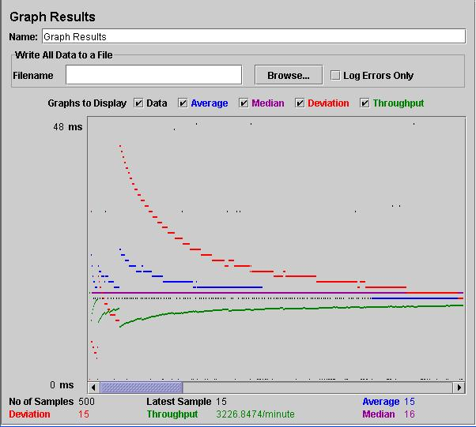 |  | String Array – 100 Elements – Axis 2.0
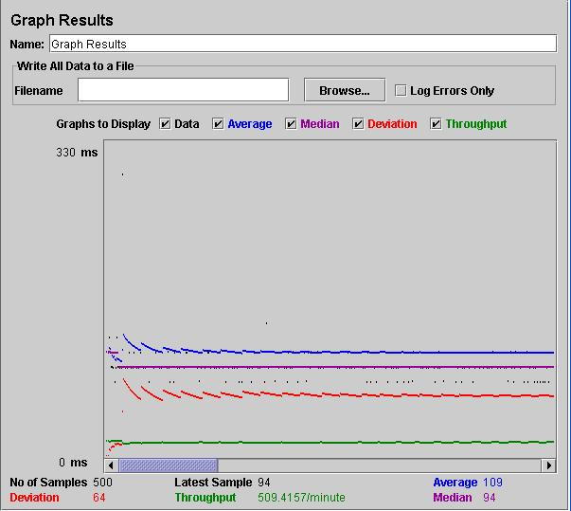 | String Array – 1000 Elements – Axis 1.2
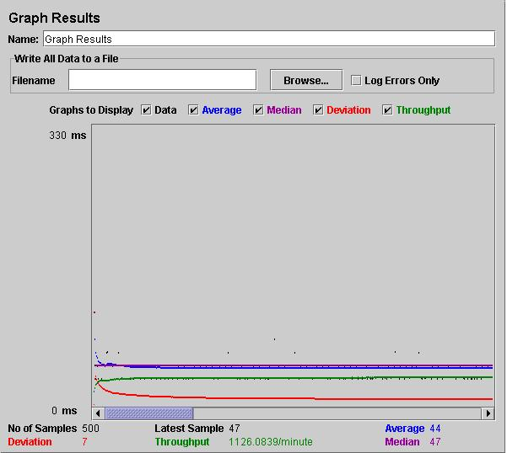 | String Array – 1000 Elements – Axis 2.0
 |  |  | Complex Array – 10 Elements – Axis 1.2
 |  |  | Complex Array – 10 Elements – Axis 2.0
 |  |  | Complex Array – 100 Elements – Axis 1.2
 |  |  | Complex Array – 100 Elements – Axis 2.0
 |  |  | Complex Array – 1000 Elements – Axis 1.2
 |  |  | Complex Array – 1000 Elements – Axis 2.0

Links
Code for the samples
- Code for Sample 1

Complete Test bundle (this includes the images, Excel sheet and the request Documents)
- Complete Test resource bundle

